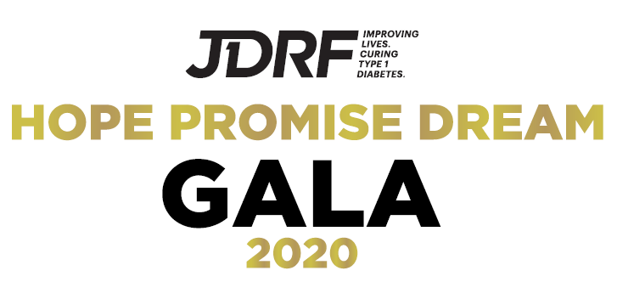

**JDRF South Florida Chapter**

**2020 Hope Promise Dream Gala**

**May, 2020**

**Location: To Be Announced**

**SPONSORSHIP OPPORTUNITIES**

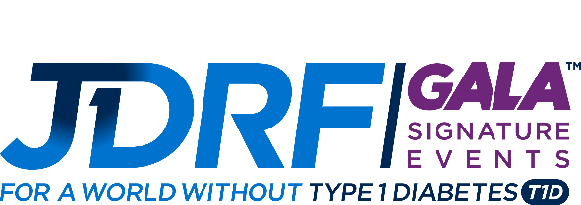

**8th ANNUAL JDRF HOPE PROMISE DREAM GALA**

**May 2020**

**6:00 PM - 11:30 PM**

***Cocktail Attire***

***Event Chairs – Mr. & Mrs. Gregg & Beth Roth***

***Mr. & Mrs. Olli & Katerina Jokinen***

***Entertainment by Private Stock***

**About JDRF:** JDRF is the leading global organization funding type 1 diabetes (T1D) research. JDRF’s goal is to progressively remove the impact of T1D from people’s lives until we achieve a world without T1D. JDRF collaborates with a wide spectrum of partners and is the only organization with the scientific resources, policy influence, and a working plan to better treat, prevent, and eventually cure T1D.

**About T1D:** T1D is an autoimmune disease in which a person’s pancreas stops producing insulin, a hormone that enables people to get energy from food. T1D strikes both children and adults and the onset has nothing to do with diet or lifestyle. People with T1D must regularly monitor their blood sugar level, inject or continually infuse insulin through a pump, and carefully balance their insulin doses with eating and daily activities throughout the day and night. Even with intensive disease management, a significant portion of the day is still spent with either high or low blood sugar levels, placing people with T1D at risk for devastating complications such as heart attack, stroke, blindness, and amputation.

***2020 Hope Promise Dream Sponsorship Opportunities***

***Breakthrough Sponsor: $25,000\****

***Exclusive Level - Only One Investment Opportunity Available***

***The Presenting Sponsor’s name will be included as part of the event name***

***“JDRF South Florida Hope, Promise, Dream Gala Presented by YOUR COMPANY NAME”***

Two royal tables of 10

Upgraded wine service

Complimentary local delivery of auction items for table guests

Express check in

One complimentary room at venue, night of the event

Logo featured on front of invitation

Logo featured on all print collateral

Logo on Website & Social Media Campaign

Logo on BidPal mobile bidding

Formal recognition by Emcee the night of the event

GOBO Logo in ballroom

Opportunity to address Gala attendees as part of the evening program

Full page advertorial and ad on the JDRF Gala Website & evening program rotating loop video

Opportunity for private research update

*Fair market value of benefits received is $3,000

***Sponsorship Levels***

|  |  |  |  |  |
| --- | --- | --- | --- | --- |
|  | ***Progress*** | ***Celebration*** | ***Vision*** | ***Hope*** |
|  | ***$15,000\****  ***\*Fair market value of benefits received is $1,800*** | ***$10,000\****  ***\*Fair market value of benefits received is $1,500*** | ***$5,000\****  ***\*Fair market value of benefits received is $1,500*** | ***$3,500\****  ***\*Fair market value of benefits received is $1,500*** |
| ***Table of*** | ***12*** | ***10*** | ***10*** | ***10*** |
| ***Upgraded Wine Service*** |  |  |  |  |
| ***Complimentary local delivery of auction items*** |  |  |  |  |
| ***Corporate representation on event committees*** |  |  |  |  |
| ***Logo on invitation*** |  |  |  |  |
| ***Logo placement on event collateral and promotional materials*** |  |  |  |  |
| ***Logo on website and social media posts*** |  |  |  |  |
| ***Logo on signage at event*** |  |  |  |  |
| ***Logo on sponsor loop at event*** |  |  |  |  |
| ***Invitation to research update*** |  |  |  |  |

**\***Print deadlines apply

***Underwriting Sponsorship Opportunities***

***Valet Sponsor: $5,000\****

*Only One Investment Opportunity Available*

4 tickets to the Gala

Logo on signage at Valet Station

Opportunity for leave behind promotional item for all guests

Formal Recognition by the Emcee

Logo presented in sponsor video loop

Logo on signage at event

Logo featured in social media posts

*Fair market value of benefits received is $600

***Cocktail Hour Sponsor: $5,000\****

*Only One Investment Opportunity Available*

4 tickets to the Gala

Formal Recognition by the emcee

Logo presented in sponsor video loop

Logo on signage at event

Logo featured in social media posts

Logo on branded cocktail hour napkins

Signage at bars in silent auction area

*Fair market value of benefits received is $600

***Entertainment Sponsor: $7,500\****

*Only One Investment Opportunity Available*

6 tickets to the Gala

Formal Recognition by the Emcee

Logo on mobile auction platform

Logo presented in sponsor video loop

Logo featured in social media posts

GOBO in the ballroom

*Fair market value of benefits received is $900

***Live and Silent Auction Sponsor: $5,000\****

*Only One Investment Opportunity Available*

4 tickets to the Gala

Formal Recognition by the Emcee

Logo presented in sponsor video loop

Logo on signage at event

Logo featured in social media posts

Logo on Bidpal mobile bidding

Logo on Live Auction bid cards

*Fair market value of benefits received is $600

***Decor Sponsor: $5,000\****

*Only One Investment Opportunity Available*

4 tickets to the Gala

Formal Recognition by the Emcee

Logo presented in sponsor video loop

Logo on signage at event

Logo featured in social media posts

*Fair market value of benefits received is $600

***Youth Ambassador Sponsor: $5,000\****

*Only One Investment Opportunity Available*

Sponsored table for Youth Ambassadors plus 4 tickets to the Gala

Formal Recognition by the Emcee

Logo presented in sponsor video loop

Logo on signage at event

Logo featured in social media posts

Branded Youth Ambassador Identifiers

*Fair market value of benefits received is $600

**\***Print deadlines apply

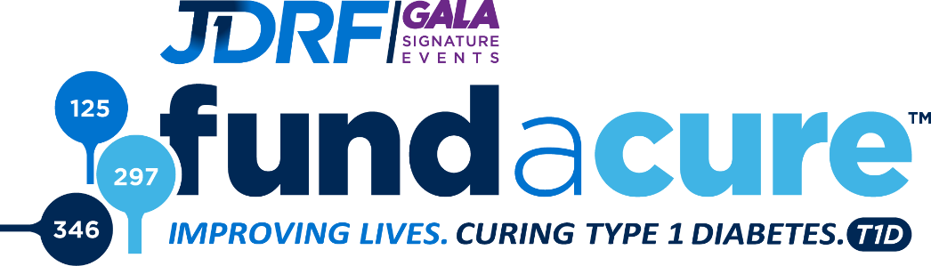

A special opportunity to be part of The Cure:

Fund A Cure is a unique opportunity for you to donate to the mission of JDRF. Since its inception in 1970, JDRF has funded virtually every major breakthrough in diabetes research. The path to a cure for diabetes is as complex as the disease itself, but tremendous progress is being made every day and the goal is in sight. Over the next years, JDRF will accelerate the pace of medical progress through a bold new research program that will be aggressively goal-oriented and closely managed.

Levels of Fund A Cure Giving*

$25,000

$10,000

$5,000

$2,500

$1,000

$500

Other

*Advanced gifts of $2,500 and higher will be recognized in the evening presentation.

Sponsorship Investment Commitment Form

Company Name:

Address:

Contact Name & Title: ______

Telephone Number: E-Mail Address: ____________

How would you like your company to be listed? ______ ______

|  |  |
| --- | --- |
| ***Sponsorship Opportunities*** | ***Exclusive Underwriting Opportunities*** |
| * $25,000 Breakthrough Sponsor | * $7,500 Evening Entertainment Sponsor |
| * $15,000 Progress Sponsor | * $5,000 Live and Silent Auction Sponsor |
| * $10,000 Celebration Sponsor | * $5,000 Decor Sponsor |
| * $5,000 Vision Sponsor | * $5,000 Valet Sponsor |
| * $3,500 Hope Sponsor | * $5,000 Cocktail Hour Sponsor |
| * $2,500 Friends of JDRF Table of Ten | * $5,000 Youth Ambassador Sponsor |

**Pre Event Fund A Cure Donation: $** _______________

**We cannot attend but wish to donate to Fund A Cure: $** _______________

**Payment Options:**

Please invoice me at the address listed above.  Check #____ ___ enclosed (made payable to JDRF)

Visa  MasterCard  American Express ~ Credit Card No. ____ _______ Exp Date: __ /__

CVV: ____ Name on Card: ________________________________

Billing Address (If different than above): ________________________________________

City: ______________________State: ______________________Zip: ________________

Signature: ________________________________________________________________

Please remit to: JDRF South Florida Chapter

3411 NW 9th Ave. Suite 701 Ft. Lauderdale, FL 33309

Questions, contact: Tracey Paige at 954.903.9455 or [tpaige@jdrf.org](mailto:tpaige@jdrf.org)

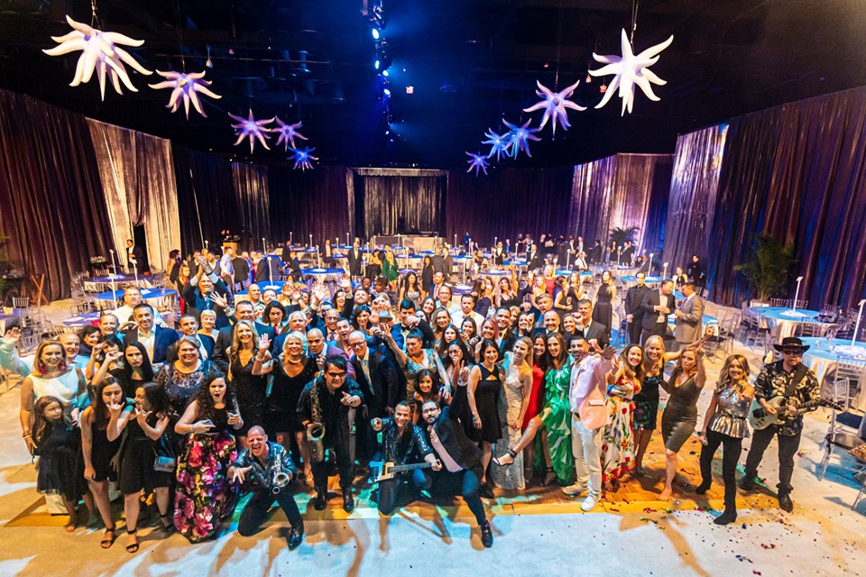

**Thank You**

**For additional questions or information please contact:**

**Tracey Paige**

**South Florida Market Director**

**954.903.9455 | tpaige@jdrf.org**